Install MadCollection
download from https://www.madshi.net/
madexcept 5.2.0 (https://madshi.net/madCollection.exe)
see madCollection folder, mad.collection.exe
Don't forget Mad except 5 and other components
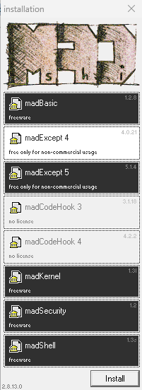
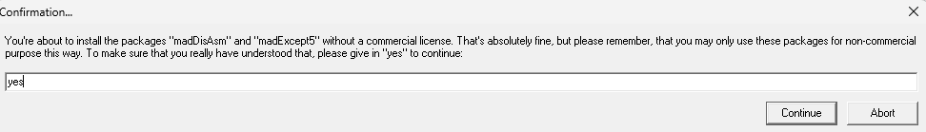

Virtual tree view
Install from Getit manager (by Jam software)
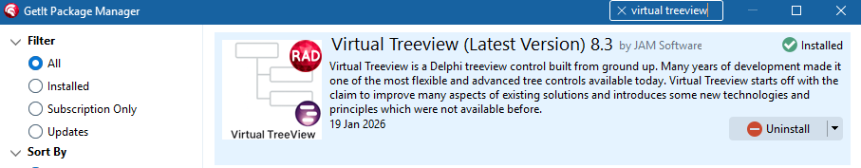

Synedit : install from get it manager
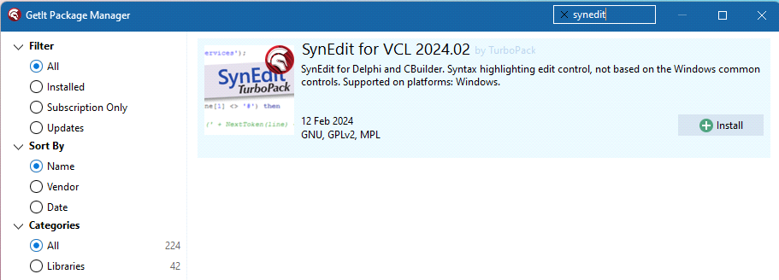
Add missing $(BDSCatalogRepository)\SynEdit-11\source\Highlighters for 32 and 64 environment
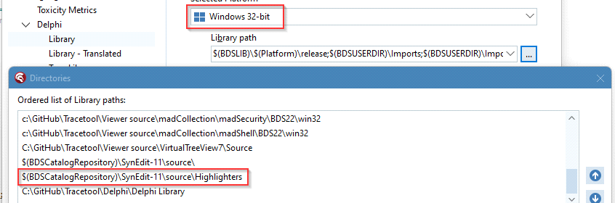
4) TPrintPreview, TThumbnailPreview
Open Preview\PreviewPackage.dproj
right click PreviewPackage.bpl, install
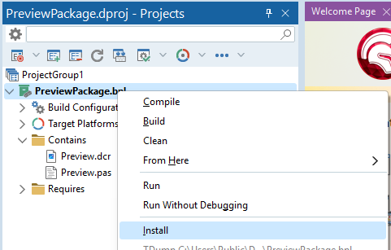

FastMM 5
Tools menu > options > Language>Delphi>Library
Add to library path (32 and 64) : PathToTracetool\Viewer source\FastMM5

Tracetool Delphi Library
Tools menu > options > Language>Delphi>Library
Add to library path (32 and 64) : PathToTracetool\Delphi\Delphi\ Delphi Library

